Loïc CURBIERE

DataScientist

 0660598245 curbierel@gmail.com 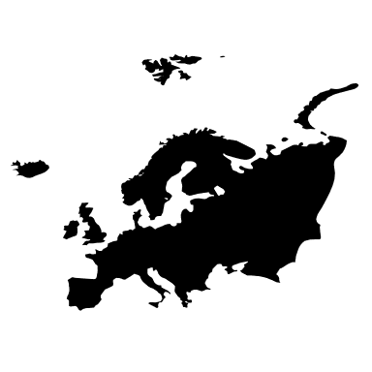 Rennes, France

|  |  |
| --- | --- |
| EDUCATION | SKILLS |
|  | |  |  |  | | --- | --- | --- | | Python | SQL | Java | | Machine Learning | Pandas | HTML/CSS | |
| EXPERIENCES | LANGUAGES |
|  |  |
|  | FIND ME ON WEB |
| EDUCATION |  |
|  |  |